**EXP NO: 3**

**AIM:** To write an assembly language program to implement 8-bit multiplication using 8085 processor.

**ALGORITHM:**

1. Start the program by loading a register pair with the address of memory location.
2. Move the data to a register.
3. Get the second data and load it into the accumulator.
4. Add the two register contents.
5. Increment the value of the carry.
6. Check whether the repeated addition is over.
7. Store the value of product and the carry in the memory location.
8. Halt.

**PROGRAM:**

LDA 8500

MOV B, A

LDA 8001

MOV C, A

CPI 00

JZ LOOP

XRA A

LOOP1: ADD E

DCR C

JZ LOOP

JMP LOOP1

LOOP: STA 8002

RST 1

**INPUT:**

**4,2**

**OUTPUT:**

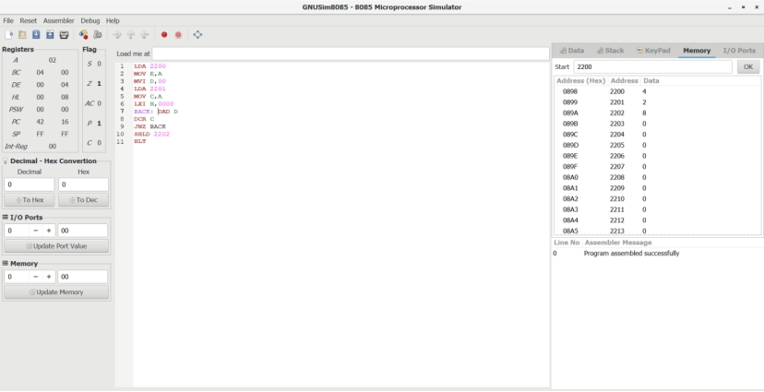

**RESULT:** Thus the program was executed successfully using 8085 processor simulator.